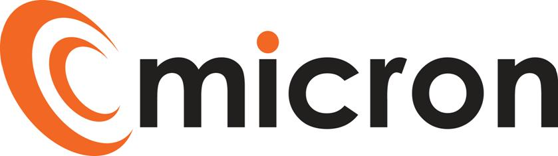
PREPRARED by: tina Whitmarsh
micron communications limited
unit 3b coldharbour business park sherborne dorset dt9 4jw

Accounts ADministrator
Version 1
June 29, 2021
Title: | Accounts Administrator
Reports to: | Head of Finance
Escalation: | Managing Director

PURPOSE OF JOB ROLE
As an Accounts Administrator you will be a key member of the team assisting with the smooth operation of the department. Working closely with the Head of Finance and Finance Assistant supporting them with day-to-day duties, data inputting and housekeeping.

KEY ACCOUNTABILITIES
Below, are a list of activities/duties generally involved in the role, some areas detailed will be secondary support. The list is non-exhaustive, and the employee will from time to time be asked to fulfil other duties as directed by the Management Team.

- Handovers from Sales team, implement on NetSuite
- Housekeeping of all platforms; Salesforce, NetSuite, Elevate (2nd line support)
- Credit card expenses / cash expenses for employees to be entered through NetSuite
- Processing of direct debits; setting up new, update existing DD mandates and monthly claim through NatWest Autopay
- Credit control; contact our debtors via email and phone and updating NetSuite (2nd line support)
- Processing purchase and sales invoices through NetSuite
- Administration of Salesforce account cases
- Raising service agreement & invoicing (2nd line support)
- Assist with the admin input and maintenance of the Elevate billing platform
- Assist with the preparation of month end
- To assist the HR Manager with the Wellbeing strategy
- Any other ad hoc duties as requested by management

QUALIFICATIONS & EXPERIENCE
- Minimum 2 years’ Admin / office experience
- Knowledge of accounts process (Advantage)
- Experience in a similar role as an Accounts Assistant (Advantage)
- Netsuite ERP (prior knowledge not essential but an advantage)
- Good knowledge of MS Office – Word, Excel, Outlook

SKILLS & BEHAVIOURS
- Proactively priorities workload
- Self-motivated and highly organised
- Exceptional attention to detail
- Excellent communication skills, verbal and written
- Enthusiasm to improve knowledge levels at every opportunity
- Excellent timekeeping and time management
- Comfortable learning software package
- Supportive and helpful team member

To be kept in staff file:-
I have read and understand all the contents of this job description. This job description describes the principal purpose and main elements of the job. It is a guide to the nature and main duties of the job as they currently exist but is not intended as a wholly comprehensive or permanent schedule and is not part of the contract of employment. Therefore, you may be required from time to time to carry out tasks requested by the Management/Directors.

Employee name: ______________________________________________________________
Employee signature: ______________________________________________________________
Date: ______________________________________________________________
HOD / HR signature: ______________________________________________________________
Date: ______________________________________________________________

