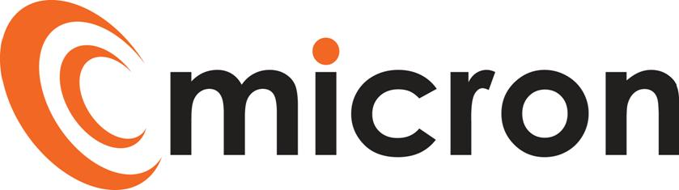

PREPRARED by: katie rochester

micron communications limited

unit 3b coldharbour business park sherborne dorset dt9 4jw

Job description

SUPPORT DESK ENGINEER (Level 1)

Version 1.6

November 24, 2023

|  |  |
| --- | --- |
| **Title:** | Support Desk Engineer (Level 1) |
| **Reports to**: | Support Desk Team Leader |
| **Escalation:** | Operations Manager |

## PURPOSE OF JOB ROLE:

As a Support Desk Engineer, you will be the first point of contact for customers with technical issues via phone and email. Focusing on level 1 cases, providing effective and remote support services for customers whilst always delivering excellent customer service.

For more complex technical issues you will be responsible for assigning the cases to the relevant level for one of the team members to respond to, ensuring clear and accurate notes are recorded in Salesforce.

Working collectively with the Support Desk team to ensure SLAs are achieved and maintained.

KEY ACCOUNTABILITIES

Below, are a list of activities/duties generally involved in the role. The list is non exhaustive, and the employee will from time to time be asked to fulfil other duties as directed by the Management Team.

* Take ownership of Level 1 cases, providing telephone/remote assistance in resolving cases prioritising and escalating as necessary
* Answer incoming calls promptly and log support cases in Salesforce
* Maximum number of cases in queue is 7
* Provide telephone/remote support assistance in resolving cases in the following areas: IT, WIFI and Connectivity
* Manage Tier 1 queue and hit milestones for cases as and when required
* Ensure cases are picked up within milestones and customer is kept up to date in line with the customer journey and SLAs
* Regularly update case tracking information in Salesforce
* Escalate cases that need advanced support or customer care
* Take part in pre-configuration of small projects
* Ensure customer documentation is kept up to date
* Achieve own KPIs and milestones
* Be a reliable part of the out of hours rota for engineer cover
* Adhere to company process and policies
* Liaise with third party software/hardware suppliers or maintenance suppliers where necessary
* Assist within the team to achieve group targets and ensure a high level of customer service are upheld
* Ensure pro-active monitoring alerts received by NinjaRMM in Salesforce are actioned or escalated as required

QUALIFICATIONS & EXPERIENCE

* 2 years’ experience in a similar role (preferred)
* Achieved the Infrastructure Technician – Level 3
* Experience in supporting IT and WiFi technologies
* Experience in Cisco IOS, configuring Cisco network equipment
* Working knowledge of Microsoft operating systems
* Have a solid understanding of how networks operate including experience in IPv4, routing and subnets
* Customer service experience

SKILLS & BEHAVIOURS

* Ability to communicate effectively in a variety of situations
* Excellent interpersonal skills, both oral and written
* A strong desire to learn, improve and succeed
* Excellent IT skills
* Effective organisational skills with the ability to plan and priorities tasks
* Ability to carry out tasks following training/direction
* Good time management skills to ensure tasks are completed and resolved in line with targets
* Confident and pleasant phone manner
* Good attention to detail
* Supportive and helpful team member
* Punctual and reliable

## 

## Working Hours

Core office hours are 8.30am to 5.30pm Monday to Thursday and 8.30am to 5.00pm Friday. The Support Desk operates an early and a late working pattern in addition to the core hours this is:

* Early 7.30am to 4.30pm Monday to Thursday and 7.30am to 4.00pm on Friday

## Training

We will support individuals to maintain their technical knowledge required for them to fulfil the requirements of their role, this will be a combination of internal training, suppliers training and the scope to include professional training courses subject to approval / budget.

Training needs will be identified through 1 to 1’s, annual reviews and development plans, this is not limited to technical knowledge it will include; customer service, soft skills and managerial, these will be discussed and agreed with the Directors and HR.

I have read and understand all the contents of this job description. This job description describes the principal purpose and main elements of the job. It is a guide to the nature and main duties of the job as they currently exist but is not intended as a wholly comprehensive or permanent schedule and is not part of the contract of employment. Therefore, you may be required from time to time to carry out tasks requested by the Management/Directors.

Employee Name: ______________________________________________________________

Employee Signature: ______________________________________________________________

Date: ______________________________________________________________

HOD/HR Signature: ______________________________________________________________

Date: ______________________________________________________________