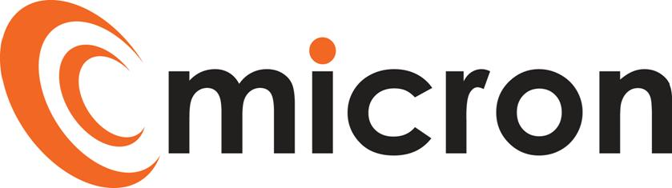
PREPARED by: KATIE ROCHESTER
micron communications limited
unit 3b coldharbour business park sherborne dorset dt9 4jw

Job description
OFFICE MANAGER
Version 1.1
March 21, 2024
Title: | Office Manager
Reports to: | HR Manager
Escalation: | Managing Director

PURPOSE OF JOB ROLE:
This is a hands-on role, assisting the Senior Leadership Team in the smooth running of the Micron Head Office. The Office Manager will help create and maintain a welcoming, clean, efficient, and fully functioning office ensuring compliance with relevant guidance and regulations. In addition, the Office Manager will provide a proactive and professional administrative support service to the Senior Leadership and HR teams.

KEY ACCOUNTABILITIES

Below, is a list of activities / duties generally involved in the role. The list is non exhaustive, and the employee will from time to time be asked to fulfil other duties as directed by the Management Team.
- Responsible for the smooth and efficient running of the office, ensuring the office remains a welcoming and functional site for all staff and making recommendations for any areas of improvement.
- Create a welcoming and professional environment for all visitors to the office.
- Advice SLT as necessary on all facilities and building issues.
- Day to day management of a fully functional office such as owning and delegating responsibility for the opening and closing of the office, acting as reception where necessary to greet visitors.
- Organising supplies within the office including drinks, snacks, stationery and ordering any catering for meetings if necessary.
- Maintain strong working relationships with external suppliers and contracts to ensure the office effective provision of outsourced services to the office including cleaning, stationery, kitchen equipment and supplies, security systems and building maintenance.
- Provide an efficient and effective support service to the Senior Leadership Team to include but not limited to diary management, correspondence, taking and distributing of meeting minutes and creating presentations.
- Efficient administrative support to the HR Manager across all aspects of HR and the employee lifecycle when at Micron including but not limited to recruitment, onboarding and induction as well as organising reviews, benefits administration and ensuring records are kept up to date at all times as well as completing reports and follow-up action.
- Assist in the creation of the monthly newsletter, helping to create content and enroll the help of others to ensure the newsletter remains relevant and informative.
- Take responsibility for the creation of training accounts for new joiners to the business through our Atlas portal, ensuring training is assigned and completed in a timely manner.
- Support the Micron business with the administration, organisation and administration on an adhoc basis for any events and social events.
- Other tasks, projects and duties as assigned by Micron.

QUALIFICATIONS & EXPERIENCE
- Proven track record in similar role which requires a high level of professionalism and confidentiality.
- Strong working knowledge and use of Microsoft office.
- Experience of delivering exceptional customer service to all levels within an organisation.

SKILLS & BEHAVIOURS
- Excellent customer service and communication skills with a friendly approach.
- Exceptional organisation and planning skills with a proven track record to coordinate multiple tasks at the same time with competing deadlines.
- A thorough and organised approach with a high attention to detail and a drive to produce high quality work.
- Ability to work with confidential information, ensuring discreetness and professionalism at all times.
- Proactive & self-motivated with a willingness to learn and take on new challenges.
- Ability to work independently and to take responsibility, seeking advice and support where necessary.
- Supportive and helpful team member with great interpersonal skills to build strong cross departmental relationships.
- Ability to work with a range of internal and external people.
- Excellent time management skills with a flexible approach and positive ‘can-do’ attitude.
TRAINING

We will support individuals to maintain their technical knowledge required for them to fulfil the requirements of their role, this will be a combination of internal training, suppliers training and the scope to include professional training courses subject to approval / budget.

Training needs will be identified through 1 to 1’s, annual reviews and development plans, this is not limited to technical knowledge it will include; customer service, soft skills and managerial, these will be discussed and agreed with the Directors and HR.

I have read and understand all the contents of this job description. This job description describes the principal purpose and main elements of the job. It is a guide to the nature and main duties of the job as they currently exist but is not intended as a wholly comprehensive or permanent schedule and is not part of the contract of employment. Therefore, you may be required from time to time to carry out tasks requested by the Management/Directors.

Employee name: ______________________________________________________________
Employee signature: ______________________________________________________________
Date: ______________________________________________________________
HOD / HR signature: ______________________________________________________________
Date: ______________________________________________________________

