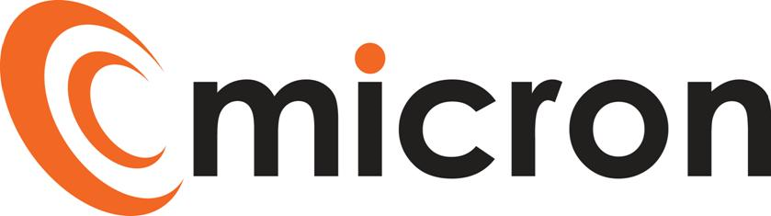

PREPRARED by: Katie Rochester

micron communications limited

Motivo House, Bluebell Road, Yeovil, BA20 2FG

Job description

SUPPORT DESK ENGINEER (Level 2)

Version 1.5

June 5, 2024

|  |  |
| --- | --- |
| **Title:** | Support Desk Engineer (Level 2) |
| **Reports to**: | Support Desk Team Leader |
| **Escalation:** | Head of Support |

## PURPOSE OF JOB ROLE:

As a Support Desk Engineer, you will be the first point of contact for customers with technical issues via phone and email. Focusing on tier 2 cases escalated to you, providing effective and remote support service for customers whilst always delivering excellent customer service.

For more complex technical issues you will attempt to resolve 2nd line cases and be responsible for assigning the cases to the relevant level for one of the team members to respond too, ensuring clear and accurate notes are recorded in Salesforce.

Working collectively with the Support Desk team to ensure SLAs are achieved and maintained.

KEY ACCOUNTABILITIES

Below, are a list of activities/duties generally involved in the role. The list is non exhaustive, and the employee will from time to time be asked to fulfil other duties as directed by the Management Team.

* Answer incoming calls promptly and log support cases in Salesforce
* Maximum number of cases in queue is 7
* Take ownership of tier 2 cases, providing telephone/remote assistance in resolving cases prioritising and escalating as necessary
* Provide support in the following areas: IT, WIFI and Connectivity
* Ensure cases are picked up within milestones and customer is kept up to date in line with the customer journey and SLAs
* Escalate cases that need advanced support or customer care
* Take part in pre-configuration of small projects
* Ensure proactive monitoring alerts received via Ninja RMM are actioned under cases
* Carry our regular pro-active checks
* Ensure Salesforce is up to date with case tracking information and customers are updated regularly
* Ensure customer documentation is kept up to date
* Provide support and guidance to Level 1 Support Desk Engineers and Apprentices
* Be a reliable part of the out of hours rota for engineer cover
* Adhere to company processes and policies
* Liaise with third party software/hardware suppliers or maintenance suppliers where necessary
* Assist within the team to achieve group targets and ensure a high level of customer service is upheld
* Achieve own KPI’s and milestones

QUALIFICATIONS & EXPERIENCE

* Minimum 2 years’ experience in a similar role
* Achieved the Infrastructure Technician – Level 3
* CompTIA A+ level 1 & 2 advantage
* Experience in supporting IT and Wi-Fi technologies
* Experience in Cisco IOS, configuring Cisco network equipment
* Working knowledge of Microsoft operating systems
* Have a solid understanding of how networks operate including experience in IPv4, routing and subnets
* Customer service experience

SKILLS & BEHAVIOURS

* Ability to communicate effectively in a variety of situations
* A thorough and organised approach
* Proactive & self-motivated
* Ability to work independently and to take responsibility
* Supportive and helpful team member
* Ability to work with a range of internal and external people
* Maintain productive, professional, and secure working environment
* Punctual and reliable

## Working Hours

We operate a 39.5 hour working week – ideally we would like to consider applicants willing to work the late shift, ideally 2pm – 10pm Monday to Friday.

## Training

We will support individuals to maintain their technical knowledge required for them to fulfil the requirements of their role, this will be a combination of internal training, suppliers training and the scope to include professional training courses subject to approval / budget.

Training needs will be identified through 1 to 1’s, annual reviews and development plans, this is not limited to technical knowledge it may include; customer service, soft skills and managerial, these will be discussed and agreed with the Directors and HR.

I have read and understand all the contents of this job description. This job description describes the principal purpose and main elements of the job. It is a guide to the nature and main duties of the job as they currently exist but is not intended as a wholly comprehensive or permanent schedule and is not part of the contract of employment. Therefore, you may be required from time to time to carry out tasks requested by the Management/Directors.

Employee Name: _________________________________________________________

Employee Signature: _________________________________________________________

Date: ­­­­­_________________________________­­­­­­­­­­­­­________________­­­­________

HOD/HR Manager: _________________________________________________________

Date: _________________________________________________________