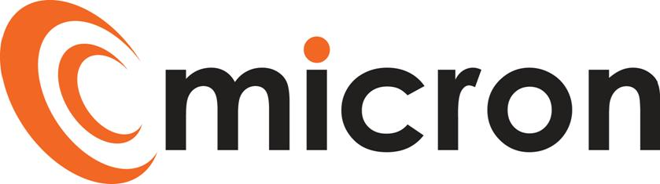

PREPRARED by: Katie Rochester

micron communications limited

Motivo, Bluebell Way, Yeovil, BA20 2FG

Job description

EXECUTIVE ASSISTANT

Version 1.1

February 4, 2025

|  |  |
| --- | --- |
| **Title:** | Executive Assistant |
| **Reports to**: | Sales Director |
| **Escalation:** | Managing Director |

## PURPOSE OF JOB ROLE:

To provide a high level, professional and pro-active executive support function to the Sales Director ensuring they are fully briefed and prepared for their activities. Focusing on agenda items, deliverables and key issues as well as helping to effectively manage workload and working with internal teams, clients and potential customers, ensuring a professional image is maintained at all times.

KEY ACCOUNTABILITIES

Below is a list of key activities associated with the role. The list is non exhaustive, and the employee will from time to time be asked to fulfil other duties as directed by the Management Team.

* Proactive diary management - arranging meetings and making travel arrangements ensuring all associated paperwork is provided and any necessary prework or action points have been organised and/or completed prior to the meeting.
* Inbox management – flagging and drafting emails and correspondence on behalf of the Sales Director or responding if needed and appropriate.
* Management of tasks, daily duties and queries on behalf of the Sales Director, with the ability to establish priorities based on an understanding of the business and strategy, ensuring to follow up to ensure completion.
* To provide high calibre administrative services in the creation of business documentation including letters, papers, reports, minutes, action points, presentations, spreadsheets and other documents as required. Ensuring deadlines are met and the output meets the Micron style and professional standards.
* Central point of contact for our Marketing agency, helping to create content such as website updates, news articles, and case studies ensuring all information is accurate and collated and shared in a timely fashion.
* Assist with the creation and evolution of the monthly Micron newsletter.
* Responsible for credit card statement and receipts, ensuring accurate information is captured and submitted on time to Accounts.
* Supporting with management of holiday requests and updating sickness records within Salesforce.
* Collation of regular monthly information to support specific activity such as agenda items for Senior Leadership Team Meetings, business highlights and Sales Meetings.
* Drafting and circulating team communications when required.
* To receive highly confidential and sensitive information, ensuring such information is handled with care and tact and using professionalism.
* To assist the HR Manager as required during peak periods.

QUALIFICATIONS & EXPERIENCE

* Proven track record in Personal/Executive Assistant role, ideally supporting a Sales Director.
* Good working knowledge of MS Office – Word, Excel, Outlook, experience working with Salesforce would be beneficial

SKILLS & BEHAVIOURS

* First class organisation skills with the ability to prioritise a busy and varied workload with ease.
* Builds trust and confidence quicky through delivering excellent work and exceeding expectations.
* Outstanding communication skills with a strong passion for exceptional customer service.
* Personable, supportive and helpful team player with great interpersonal skills to build strong cross departmental relationships with a creative approach to problem solving.
* Acts with integrity at all times with the ability to handle confidential and sensitive information with discretion.
* Resilient and self-motivated with a flexible approach and ‘can-do’ attitude.
* Comfortable using independent judgement to priortise work schedules in accordance with changing priorities, liaising and negotiating with all relevant parties in an efficient and effective way.
* A talent for maintaining calm and order within a demanding environment which is subject to busy and sometimes unexpected periods.
* Ability to work proficiently with a range of internal and external people.

TRAINING

We will support individuals to maintain their technical knowledge required for them to fulfil the requirements of their role, this will be a combination of internal training, suppliers training and the scope to include professional training courses subject to approval / budget.

Training needs will be identified through 1 to 1’s, annual reviews and development plans, this is not limited to technical knowledge it may include; customer service, soft skills and managerial, these will be discussed and agreed with the Directors and HR.

I have read and understand all the contents of this job description. This job description describes the principal purpose and main elements of the job. It is a guide to the nature and main duties of the job as they currently exist but is not intended as a wholly comprehensive or permanent schedule and is not part of the contract of employment. Therefore, you may be required from time to time to carry out tasks requested by the Management/Directors.

Employee name: ______________________________________________________________

Employee signature: ______________________________________________________________

Date: ______________________________________________________________

HOD / HR signature: ______________________________________________________________

Date: ______________________________________________________________